Rotation Manager

Those libraries participating in block rotations will see a new menu option:
Reminder: you should send out an old block before receiving a new one.

Initial set-up

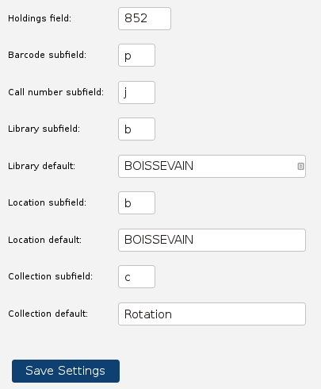
Before working with your rotation items, you'll need to do one minor bit of set-up. Click on “Holdings setup” to configure the rotation manager with your ILS holdings information.

Enter the field and various subfields that your ILS expects to find holdings information in.

You can set up default values for Library, Location, and Collection; if you leave these blank, fILL will automatically set the Library and Location defaults to be your library symbol, and the Collection default to “Stacks”.

Click the “Save settings” button when you're done.

Setting this up will enable the rotation manager to export MARC records configured for your system.

Receiving a block of items
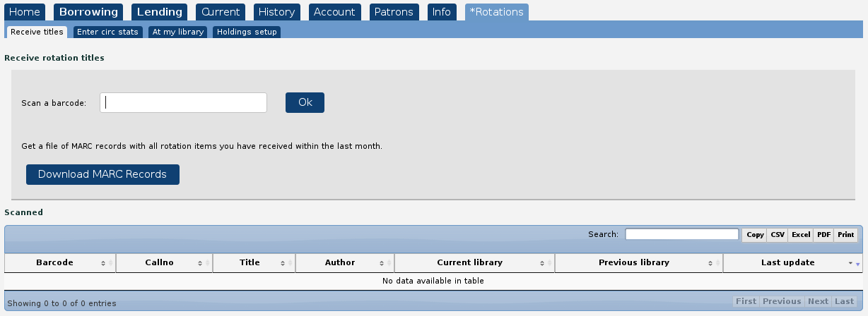
When you get a new block of titles, click on “Rotation manager” => “Receive title” to let the rotation manager know you've received them.
As you unpack the books, scan each barcode into the “Scan a barcode” box; the book will be added to the list:
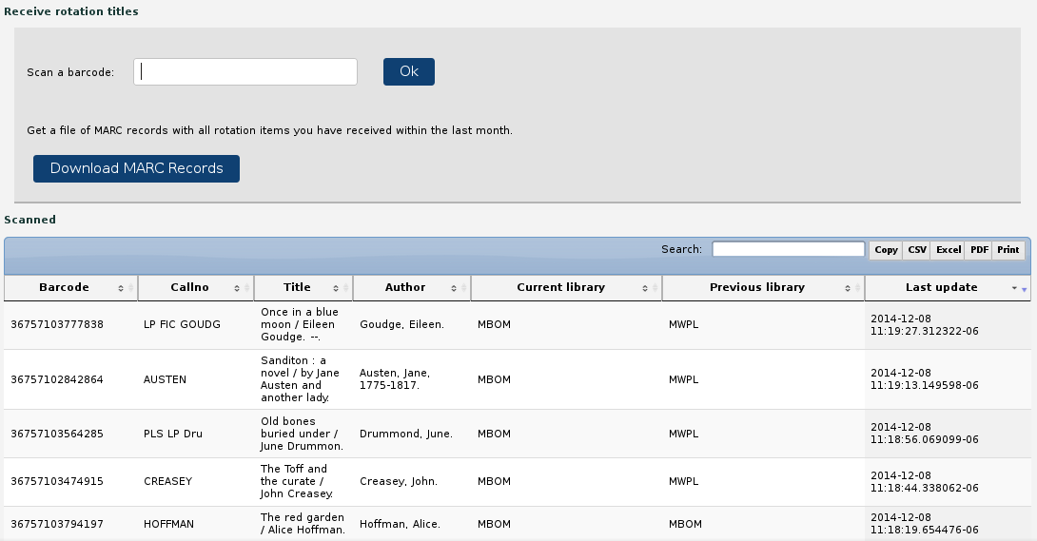
The most recently scanned item will be the top-most line.

Note that the rotation manager knows the title/author/call# details; these are filled in automatically.

Your library symbol will appear in the “current_library” column; the library you've received from shows up in the “previous_library” column.

“Timestamp” is the date and time that you've received the item.

Downloading MARC records
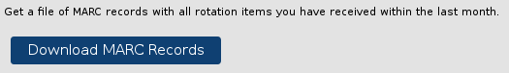
Once you've finished scanning in the barcodes, click the “Download MARC records” button.

The rotation manager will create a file of MARC records, using the holdings field information you've set up in “Holdings setup”.
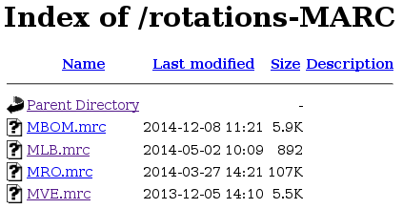
This file will contain records for all rotation items currently at your library. (So it makes sense to ship out the outgoing items before scanning the incomming items....)

A new browser window will open up with a list of files.

Click on the file name that matches your library symbol to download the file.

You can then import the file into your ILS.

SPRUCE libraries will not have to import records (recs are already in Evergreen).

Shipping out a block
Before you ship a block on to the next library, PLS requires that you enter the circulation statistics your ILS has collected for those items.

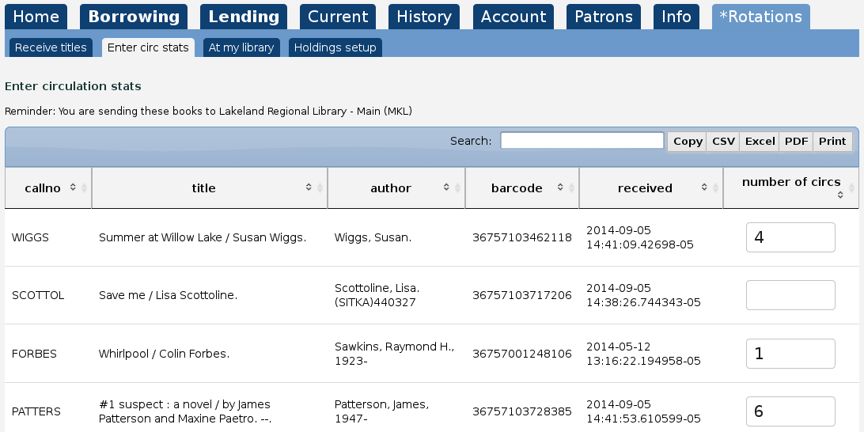
Go into “Rotation manager” => “Enter circ stats”

This is a list of all rotation items currently at your library.

Enter the number of circulations each item has had (from when you received the item until now).

The rotation manager does not try to enforce a particular method of doing this; a couple of options would be:
- Print the list, fill in the circ counts from your ILS, and return here to enter the data (pressing the TAB key after entering a number will take you to the next line).
- Alternatively, scan the item barcode into your ILS to find the number of circs, click in the “Search” box on this table, and scan the item barcode to bring up just that item and enter the # from your ILS.

Once you've entered the circ stats, remove the items from your ILS and send the block to the next library.

At my library

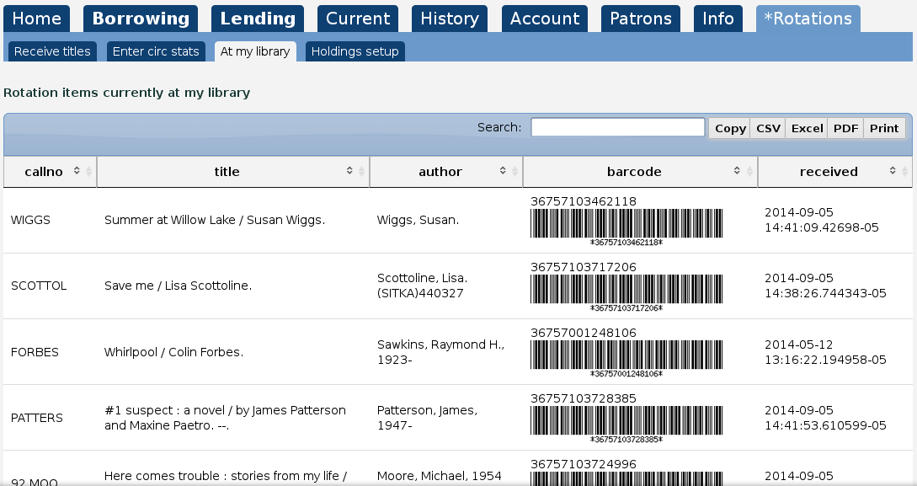
The “At my library” screen is simply a convenience – it lists all of the rotation items that are currently at your library.

Items will get removed from this list as the next library in the rotation receives them.

